**Project Design Phase-II**

**Data Flow Diagram & User Stories**

|  |  |
| --- | --- |
| Date | 31 January 2025 |
| Team ID | LTVIP2025TMID48259 |
| Project Name | Plugging into the Future: An Exploration of Electricity Consumption Patterns using Tableau |
| Maximum Marks | 4 Marks |

**Data Flow Diagrams:**

A Data Flow Diagram (DFD) is a visual representation of the flow of information in a system. For this project, the DFD outlines how electricity consumption data is collected, cleaned, analyzed, and visualized in Tableau to extract insights for policymakers, utility companies, and analysts.

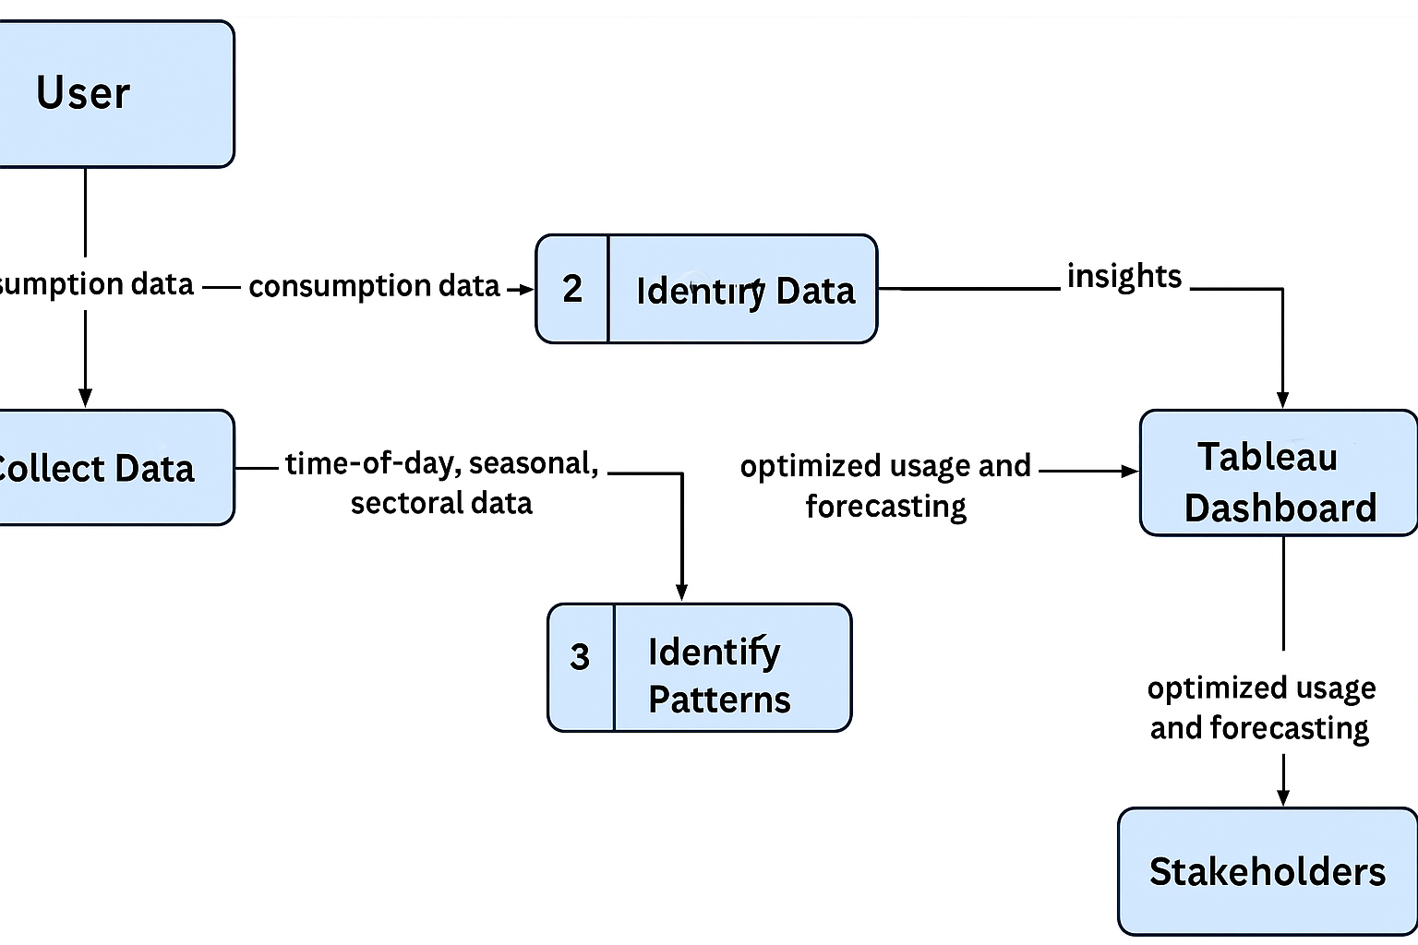

**User Stories**

| **User Type** | **Functional Requirement (Epic)** | **User Story Number** | **User Story / Task** | **Acceptance criteria** | **Priority** | **Release** |
| --- | --- | --- | --- | --- | --- | --- |
| Analyst | Data Collection & Cleaning | USN-1 | As a data analyst, I want to upload and clean electricity usage data for visualization. | Data is cleaned and ready for analysis in Tableau | High | Sprint-1 |
| Analyst | Data Categorization | USN-2 | As an analyst, I want the data categorized by sector (residential, commercial, industrial). | Sectors appear in Tableau filters and views | High | Sprint-1 |
| User | Time-of-Day Usage Trends | USN-3 | As a utility manager, I want to visualize hourly electricity usage to identify peak demand times. | Dashboard shows hourly usage trends with peak/off-peak highlights | High | Sprint-2 |
| User | Seasonal Forecasting | USN-4 | As a policymaker, I want to compare seasonal electricity demand for proactive planning. | Seasonal line chart displays annual consumption fluctuations | High | Sprint-2 |
| Analyst | Sector-Based Visualization | USN-5 | As a data analyst, I want separate views for residential, commercial, and industrial users. | Dashboards segmented by sector are visible | Medium | Sprint-3 |
| Viewer | Tableau Story Integration | USN-6 | As a viewer, I want a combined Tableau Story with all key insights (time, season, sector). | Tableau story includes all dashboards with clear filters and navigation | Medium | Sprint-4 |